Lifespan

Office of Research Administration

Instructions for Taking Lifespan Human Subjects Protection course, both Initial and Re-certification. HIPAA for Researchers is included in both courses. If you require just the HIPAA course or the GCP course the instructions will walk you though that as well.
_____________________________________________________________________

1. Log Onto the Citi Program web site
URL for the CITI course and exam: http://www.citiprogram.org

- REGISTRATION:
a. Register for the CITI course as a new user. Do not select “already registered” unless you have registered at CITI as a Lifespan Corporation Research Community person already.
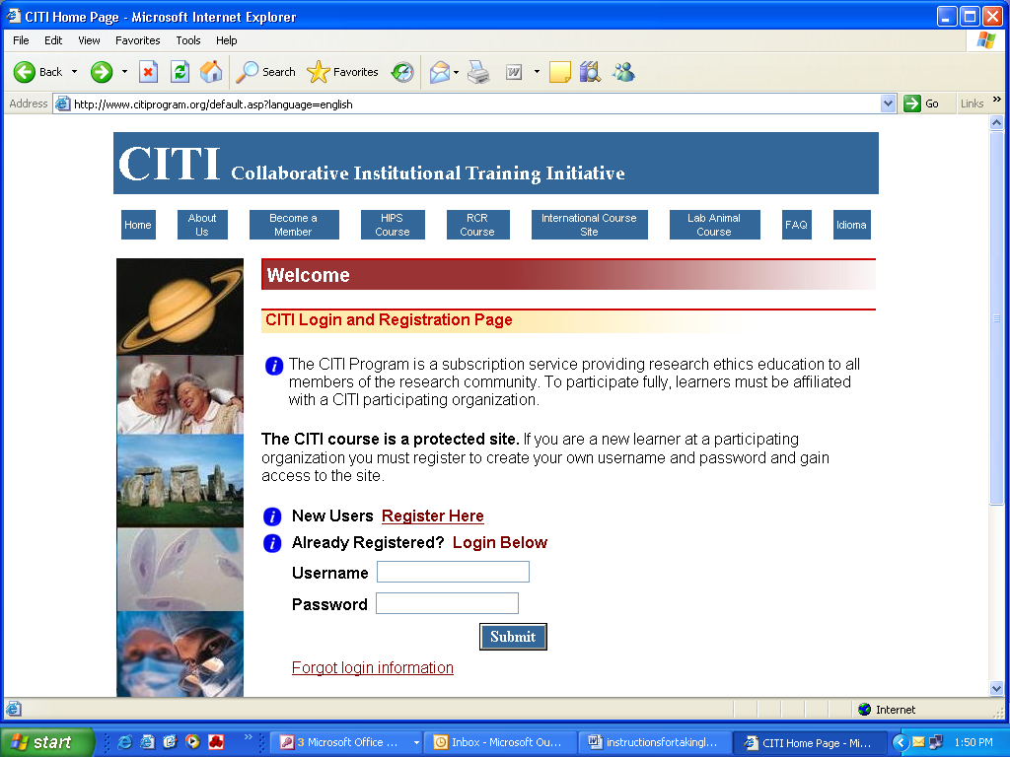

b. The CITI Program for the Protection of Human Research Subjects is a subscription service to research organizations. All users of this program must be affiliated with a participating organization. The next screen will ask you to select you Institution. Select Lifespan Corporation from the drop down list of participating institutions then click Submit.
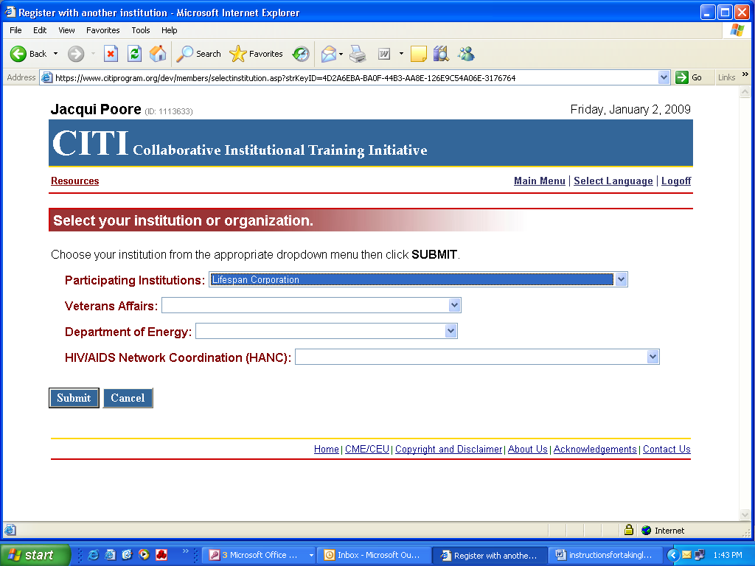

c. The CITI course is a protected site. If you are a new learner at a participating organization you must register to create your own username and password and gain access to the site.
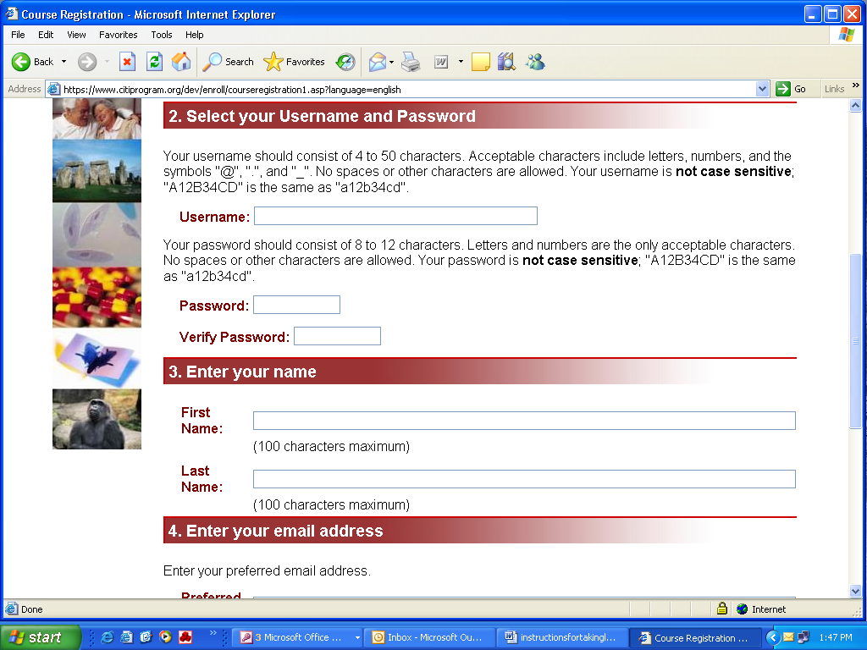

d. Follow instructions to self register
________________________________________________________________

- Course Selection
Once you hit submit the course options will come up next. Select the Basic Human Subject Protection (HSP) Course under question 1 if you have never certified in human subject protection. Select Refresher/Recertification under question 3 if you previously completed HSP certification. Select Annual HIPAA Renewal under question 2 if you only need to renew your HIPAA training. All other choices including the GCP course and are optional at this time unless specifically required by the IRB or one of the other research review committees. After you have made your selection(s), scroll to the bottom of the screen and click Submit

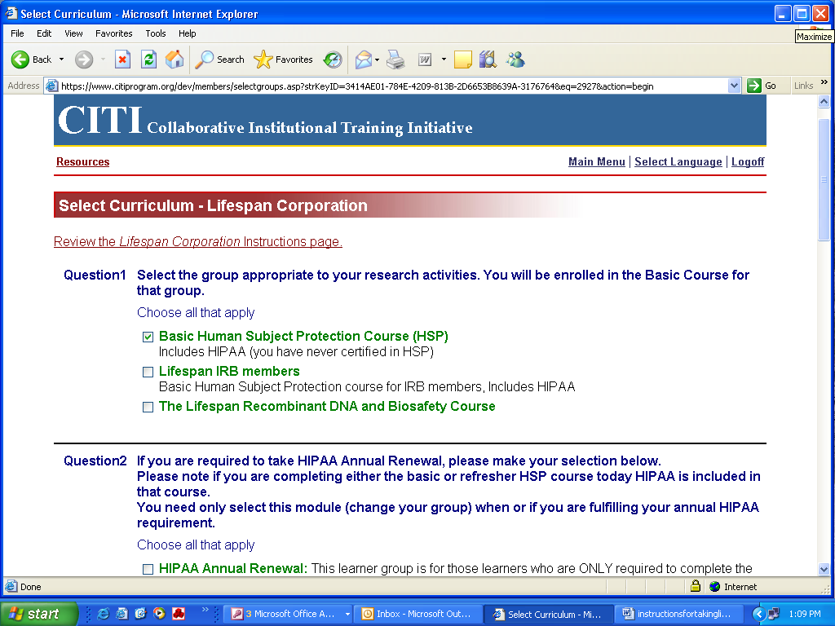

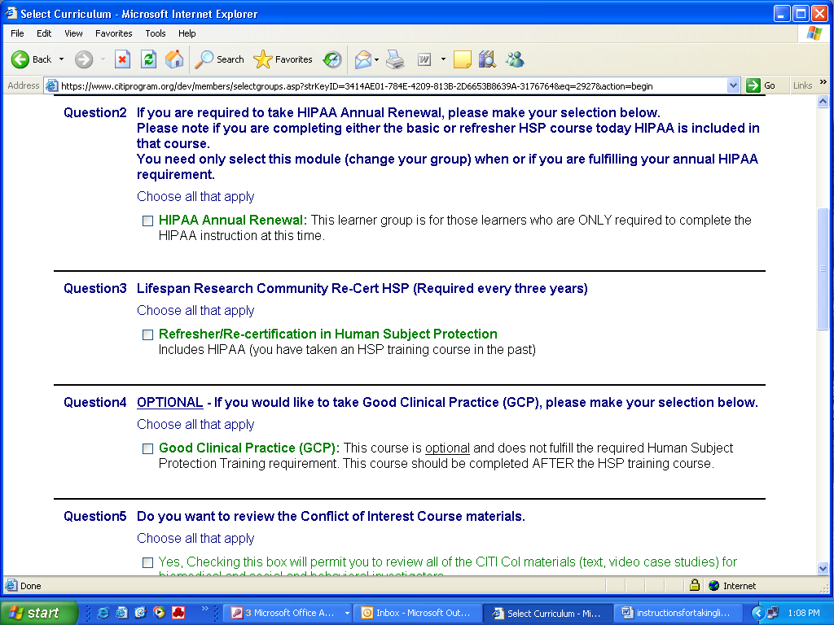
- Verify your Course Selection(s)
After you have made your selections, the Lerner’s Menu will appear. If your selected courses are correct, click on the Go Back to Learner’s Main Menu link. If you are not enrolled for the correct course(s), click on the Update Groups link and reselect the desired courses.
______________________________________________________________________
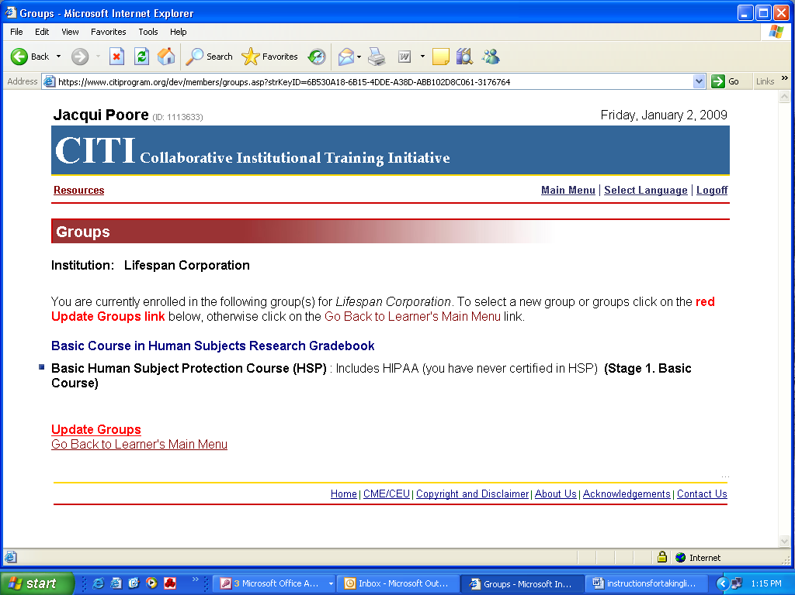

- Enter your selected course through the Main Menu-
a. This is what you will see when you select the Learner’s Main Menu. If you are affiliated with more than one institution, you can add other institutions at this time. Each institution that you designate will receive a copy of your course and test results. To begin the selected course, click on the link to Enter
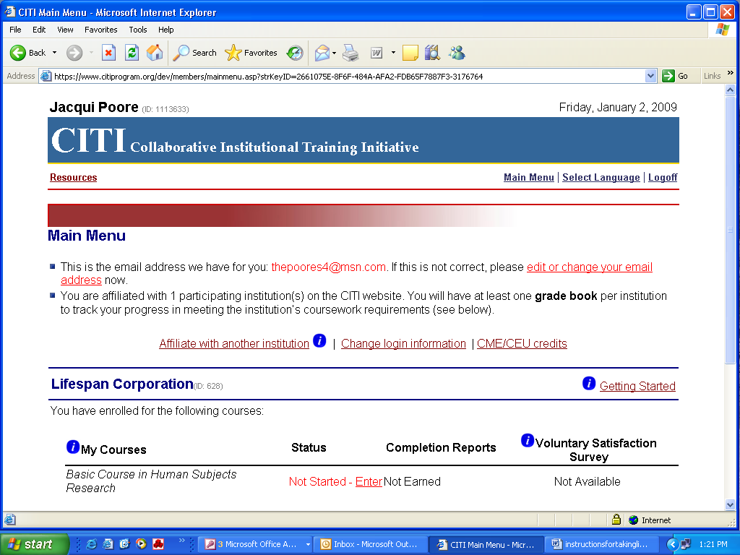

b.This is the list of modules for the Basic Course. Complete the Integrity Assurance Statement, and then proceed to complete each of the required modules.

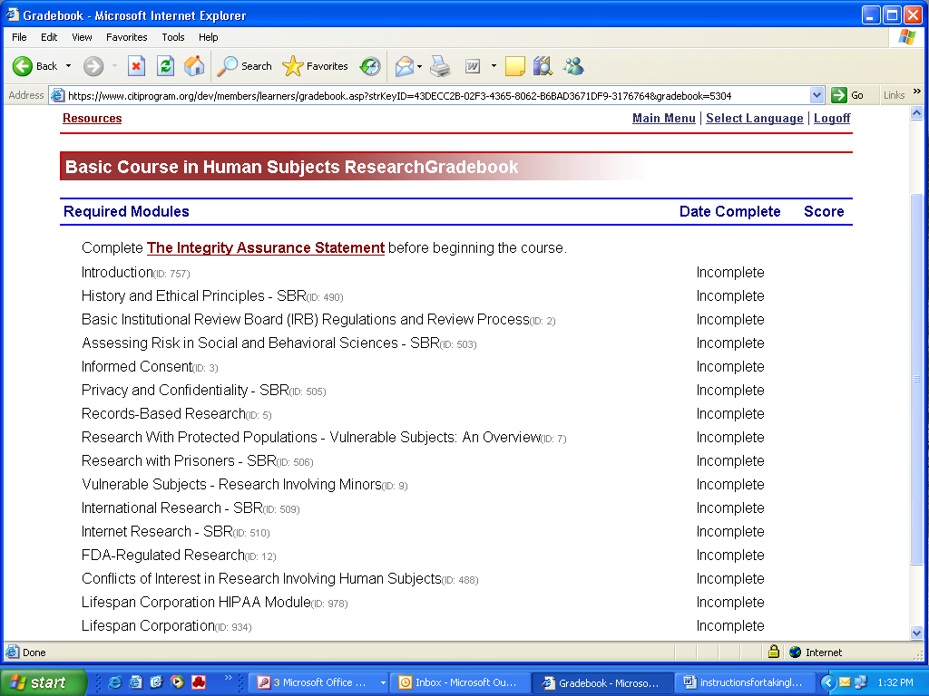

c. Please be sure to print off a certification for documentation once you have completed the course and exam.

- Changing your profile, or Adding a Course
If you have already completed one of the courses and you want to complete another, such as annual HIPAA requirement or the GCP course you will need to return to the Main Learners Menu and click on the link to Add a course or update your learner groups for Lifespan Corporation

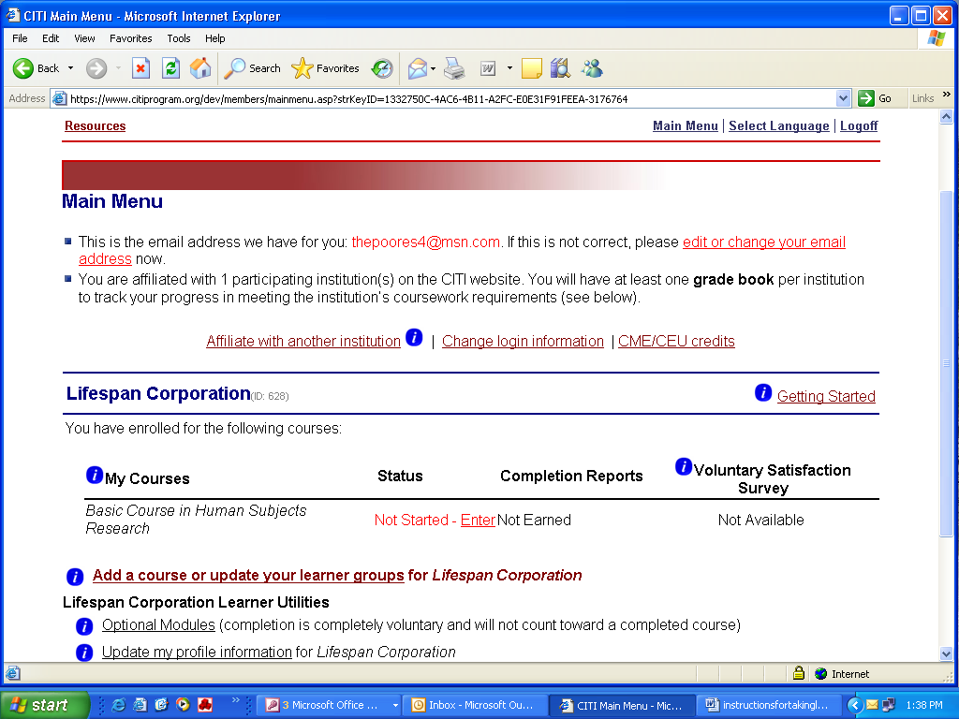

Proceed with whatever course you now want to complete.

Thank you for taking these mandatory Human Subjects Protection and HIPAA courses. Your efforts are helping Lifespan maintain our high standard of research and ensure protection for all research participants.

